| ***PAID*** |
| --- |
| ***Voting*** |
| ***Y N*** |

**IMPERIAL COURT OF NEW YORK, Inc.**  

**93 4th Ave, #269**

**New York, NY 10003**

**Membership Application**

***Date: / / .***

**Please print legibly.**

**Check** one of the following:

* **$60 NEW MEMBER - SEPTEMBER (prorated outside September)**
* **$60 RENEWING MEMBER**

**Your “LEGAL NAME”: _________________________________________________________**

**Your “COURT NAME”: __________________________________________________________**

**Permanent Home Address: ________________________________________________________**

**City: ______________________________ State: ___________ Zip Code:** ___________________

**Home Phone: __________________________ Cell Phone: ___________________________**  **Work Phone:_____________________________ May we call you at work?** ❑ **Yes** ❑ **No**

**Email address: ______________________________________ Year Joined: ________________**

**Referred by (for new members only) Occupation: ____________________**

**Birth date:Month: Day: . Facebook User Name:________________**

**Areas of Interest: (Please check as many committees you would like to participate in)**

| ❑Advertising/Marketing❑Decorating | ❑Journal ❑Performing ❑Video |
| --- | --- |
| ❑Art/Graphics ❑Food Preparation | ❑Legal ❑Photography ❑Website |
| ❑Computers/Data❑Fund Raising | ❑PR / Promotion ❑ScriptWriting ❑Stage Work |
| ❑Costuming/ Sewing ❑Hair/Makeup | ❑Newsletter/Writing ❑ Corp. Sponsorship |
| ❑Dance/ Music ❑Jewelry | ❑Admin Work ❑Tech Crew/Set Construction |

* Other: _____________________________________________________________________________________

**Please print your name in ONE of the following statements and SIGN below:**

1. I, ________________, hereby release and relinquish any and all rights that I may have, unto The Imperial Court of New York, Inc., for usage, display, publication and/or reproduction of any kind in any media, including but not solely limited to televised, photographic, newspaper, magazine or electronic/computer-based to use and reproduce (at their sole and absolute discretion) any and all photographs or reproduction thereof taken of me, by anyone, at any function of the Imperial Court of New York at any time now and in the future,
2. I, __________________, do not wish to allow The Imperial Court of New York, Inc. to use any photograph or reproduction thereof, taken of me, by anyone, at any function of The Imperial Court of New York, Inc. now or any time in the future.

*Do you or any member of your immediate family have a relationship with any company or organization which might pose a conflict of interest with the work of the Imperial Court of New York? If so, what is that relationship?*

*_____________________________________________________________________________________________________________*

**I, the undersigned, agree to abide by the Bylaws of The Imperial Court of New York, Inc. I understand that membership in good standing is contingent upon adherence to these Bylaws, payment of annual membership dues, attendance at 50% of the monthly General Membership meetings, attendance at three events and proper behavior at all Court functions.**

**SIGNATURE: _________________________________________________________ DATE: _______________________**

**QR Code for payment**

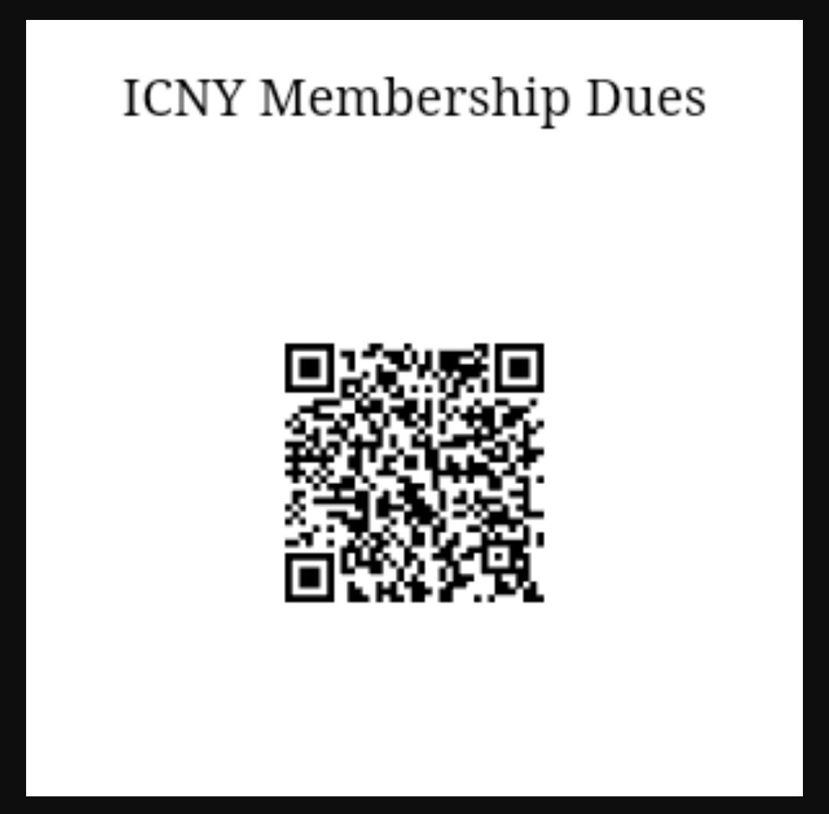

**BOARD APPROVAL: ___________________________________________________________________________**

www.icny.org